Automation framework

# Windows Host Installer – Automatically process

1. Refer to Internet Explorer and make sure that the proxy settings were set as follows:
   * proxy-chain.intel.com
   * ports: 911, 912
   * 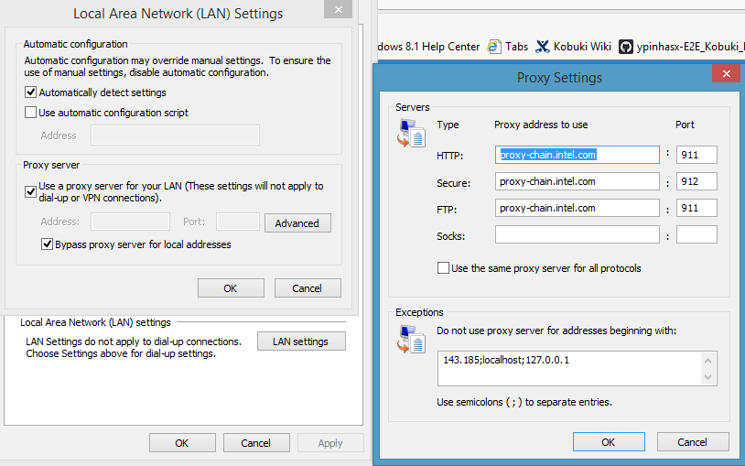
2. Refer to Secure GIT and download the [**Install_windows_host.exe**](https://git-ger-8.devtools.intel.com/gerrit/gitweb?p=perc_hw_rsautolabs-rs_autolabs.git;a=blob;f=host/setup/Windows/Output/Install_windows_host.exe;h=100848a16f8e3306457c26782e87612f79173286;hb=HEAD;tflink=projects.perc_hw_rsautolabs/scm.RS_AutoLabs)file into your desktop**.**
3. Log in into the **Nuc** **with the user that you are going to work with** and past the[**Install_windows_host.exe**](https://git-ger-8.devtools.intel.com/gerrit/gitweb?p=perc_hw_rsautolabs-rs_autolabs.git;a=blob;f=host/setup/Windows/Output/Install_windows_host.exe;h=100848a16f8e3306457c26782e87612f79173286;hb=HEAD;tflink=projects.perc_hw_rsautolabs/scm.RS_AutoLabs)file.
4. Right click on the [**Install_windows_host.exe**](https://git-ger-8.devtools.intel.com/gerrit/gitweb?p=perc_hw_rsautolabs-rs_autolabs.git;a=blob;f=host/setup/Windows/Output/Install_windows_host.exe;h=100848a16f8e3306457c26782e87612f79173286;hb=HEAD;tflink=projects.perc_hw_rsautolabs/scm.RS_AutoLabs)file and run it as Administrator.
5. Press always the ‘**Next’** button, **don’t change anything**!
6. The installation process will take a while.
7. Restart the **Nuc** at the end of the installation process.
8. Install **vc_redist.exe** x86/x64 
9. In order to make sure that the installation process completed successfully:
   * Log in again and refer to console (type cmd)
   * Type: **python C:\users\<current user name>\** **rs_autolabs\host\HostManager\HostManager.py**
   * The following message line should appear: **waiting for queue**
   * In case of getting erroe message Numpy not found please refer to PIP, type: **pip uninstall numpy**, and then: **pip install -Iv numpy==1.13.3**
10. In order to install **LibRealsense x.xx** please refer to: <https://github.com/intelrealsense/librealsense/releases>
    * Press the link: [**Intel.RealSense.SDK.exe**](https://github.com/IntelRealSense/librealsense/releases/download/v2.10.0/Intel.RealSense.SDK.exe) and select the default instructions.
    * Refer to Environment variables editor and change the values of the keys:
      + **REALSENSE_DRIVER** to: **LIBREALSENSE28**
      + **In case of LRS 2.9.X, 2.9.10 change it to: LIBREALSENSE29**
      + **BINDING_PATH** to: **C:\Program Files (x86)\Intel RealSense SDK 2.0\bin\x86**
    * Go to step 13.
11. ~~In order to install LibRealsense 2.6:~~
12. ~~Install Cmake from:~~ [~~https://cmake.org/download/~~](https://cmake.org/download/) ~~(Preferred:~~ [~~cmake-3.8.2-win64-x64.msi~~](https://cmake.org/files/v3.8/cmake-3.8.2-win64-x64.msi)~~)~~
13. ~~Installing the libRealsense:~~

* ~~Refer to~~ [~~https://github.intel.com/PercHW/librealsense~~](https://github.intel.com/PercHW/librealsense) ~~and clone libRealSense sources as zip file into: C:\users\<userName>~~
* ~~Start CMake application and configured as follows:~~
  + **~~Where is the source code:~~** ~~C:/Users/admin/librealsense~~
  + **~~Where to build the binaries:~~** ~~C:/Users/admin/librealsense/build~~
  + ~~Press the Add Entry button and add: CMAKE_BUILD_TYPE release~~
  + ~~Press~~ **~~Configure~~** ~~then~~ **~~Generate buttons~~** ~~(A warning message would appear)~~
  + ~~The CMake tool will generate the solution project file: “C:\Users\admin\librealsense\build\Realsense.sln”~~

~~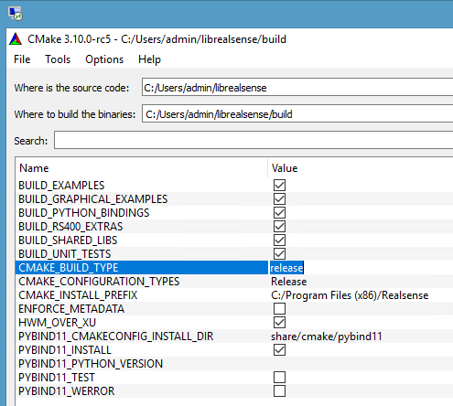~~

* ~~Start Visual Studio and open the solution file:~~ **~~C:\Users\admin\librealsense\build\Realsense.sln~~**
* ~~Rebuild the solution~~
* ~~Connect camera device to the Nuc.~~
* ~~Refer to rs-config-ui Example, press mouse right click->Debug->Start new Instance~~
* ~~The following screen should appear:~~

~~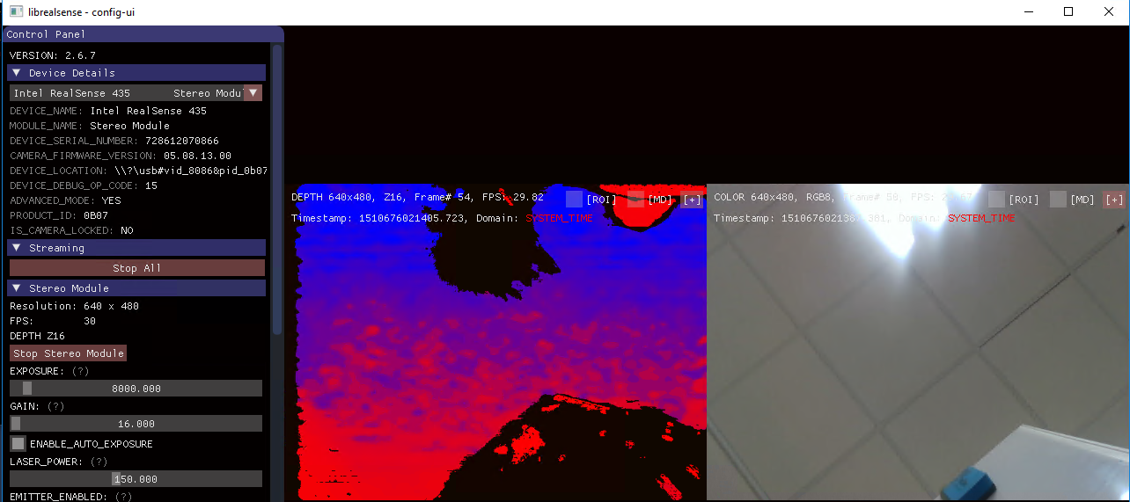~~

* ~~Further info can be found here:~~ [~~https://github.intel.com/PercHW/librealsense/blob/master/doc/installation_windows.md~~](https://github.intel.com/PercHW/librealsense/blob/master/doc/installation_windows.md)
* [~~https://github.intel.com/PercHW/librealsense/blob/v2.6.7/doc/installation_windows.md#enabling-per-frame-metadata~~](https://github.intel.com/PercHW/librealsense/blob/v2.6.7/doc/installation_windows.md#enabling-per-frame-metadata)
* **Or** Install IPDev (setup.exe) in order to enable the registry with the per frame metadata for windows (\\ger\ec\proj\ha\perc\Hardware_Releases\2017_WW51\RC\IPDev\6.2.0.0).
* ~~Install the patch that fixes the System timestamp:~~
  + ~~Download as ZIP:~~ [~~https://github.com/IntelRealSense/librealsense~~](https://github.com/IntelRealSense/librealsense)
  + ~~Extract to: C:\temp~~
  + ~~Open Power shell as administrator~~
  + ~~Refer to cd to: C:\temp\librealsense-0cc659d985af42f311b2c1c6aa9664d17133621d\scripts~~
  + ~~Type: .\realsense_metadata_win10.ps1 -op install_all~~
  + **~~Please note:~~** ~~The file size should be 7K and not in HTML format. Since sometimes during download it becomes HTML (Anti-Virus issue?)…~~

~~For Windows only: Install the Patch for Timestamp issue as described here: https://github.com/IntelRealSense/librealsense/blob/v2.9.1/doc/installation_windows.md#enabling-metadata-on-windows~~

1. Install Open SSH server:
   * ~~Install openSSH from C:\Users\admin\rs_autolabs\host\setup\Windows\ setupssh381-20040709.zip~~
   * Refer to C:\temp and extract **OpenSSH-Win64.zip** to C:\temp
   * Refer to **Environment Variables -> System Variables -> Path** and make sure that the path: **C:\OpenSSH-Win64** exist

* Open the **Windows Settings app** and go to Update and Security: For developers.
* Switch to Developer mode and wait for it to finish downloading any packages.

If you’re asked to reboot after the previous step, do so now.

* Turn on the Device discovery option.
* ~~In case of SSH connection failed try install~~ **~~putty~~** ~~then refer to developer mode.~~

~~This will enable the SSH Server Broker (SshBroker.dll) and SSH Server Proxy (SshProxy.dll)~~

~~background services which will handle incoming connections to TCP port 22.~~

* ~~Refer to Services:~~
  + ~~Service names:~~ 
    - **~~SshBroker~~** ~~(SSH Server Broker) and~~ **~~SshProxy~~** ~~(SSH Server Proxy)~~
    - ~~Change start up type to:~~ **~~Automatic~~**
    - ~~Press the~~ **~~Start~~** ~~button~~
* In order to check it refer to another machine->Console then type:

ssh user@machine name for example: **ssh admin@percdsk297**

1. In case of using the Valkyrie image quality inspection create a shortcut in your desktop as follows:
   * **Path:** //rslabs-nas.iil.intel.com/VIDB
   * **User:** valkyrie_boss
   * **Password:** Nd?WvO46h3Ki:nT%5r03
   * **Domain:** rslabs-nas
2. In case of error: **KeyError: u'Intel RealSense USB2'** refer to the NUC device and flip the USB Type-C cable.

Good luck ☺